Instructions
- This is an open-notes, open-book, open-Internet exam.
- You have 3 hours to complete this exam.
- You will not be penalized on trivial syntax errors, such as a missing parenthesis. Multiple errors or errors that lead to ambiguous code will have points deducted, however.
- In all of the questions, feel free to write additional helper methods to get the job done.
- The emphasis is on correctness of the code, not efficiency or on simply generating the right result.
- You are free to use any code that was given to you in the lectures and labs.

Please write and sign the Rice Honor Pledge here:

1 | 2 | 3a | 3b | 3c | 3d | Total
/15 pts | /25 pts | /15 pts | /15 pts | /15 pts | /15 pts | /100 pts
- (15 pts) Lazy Evaluation: Write an ALazyEval , called lrs.lazyEvals.LazyLambdaEval, that creates an infinite lazy LRStruct containing a functional expansion of a function of one variable.

Consider an infinite series representation of a function of one variable, S(x):

$$S(x)=f_{0}\left(x\right)+f_{1}\left(x\right)+f_{2}\left(x\right)+f_{3}\left(x\right)+⋯=\sum_{n=0}^{∞}{f_{n}(x)}$$

A classic example of this would be a Taylor series approximation of a continuous function. For instance, consider the Taylor series expansion of the sine function:

$$\text{sin}(x)=x−\frac{1}{3!}x^{3}+\frac{1}{5!}x^{5}−\frac{1}{7!}x^{7}+⋯=\sum_{n=0}^{∞}{\frac{{\left(−1\right)}^{n}}{(2n+1)!}x^{2n+1}}$$

This can be represented in the computer as an infinite lazy list where each term of the Taylor series is an element in the lazy list. Instead of holding simple numerical values in each element of the list, the list holds functions (“lambda functions”) of one variable.

To make testing a little easier, instead of usual input of the sine function in radians, we will scale the input parameter by a factor of π, thus creating a function where the input is in terms of factors of π (Math.PI). That is, an input of “1” is equivalent to an input of “3.1415926…” .

The n’th element of our lazy list would thus hold the following function:

$$f_{n}(x)=\frac{{\left(−1\right)}^{n}}{(2n+1)!}{\left(π⋅x\right)}^{2n+1}$$

We will use a generic lambda function interface to represent the above function:

package fp;

public interface ILambda {
Object apply(Object ... params);
}

You are to write an ALazyEval called LazyLambdaEval that will create an infinite list representing the Taylor series expansion of the sine function. The stub code for this class has been provided.

Some important information:

- The supporting code will call the above ILambda with one input parameter of type Number.
- Number has a method called doubleValue() that returns its value as a double.
- Do not recalculate (2n+1)! every time.
- Remember that for every increment of n by one, (2n+1) increments by two! Thus, (2n+1)! increments by two factors, 2n and 2n+1 for every increment of n.
- Include a toString() method on your ILambda function that will return a short String giving useful information about the coefficients and other parameter of the lambda function. This is what will be displayed on the screen display of the list and will help you determine if your code is working properly.
- To test your code:
  - Select the “Lambda list” check box.
  - The “Sum N Lambda terms” button will sum the number of terms of the list specified by “Input/Output A” with the input value given by “Input/Output B”. The result will be displayed in “Input/Output B”.
  - Test values (> 10 terms):
    - 0 → 0.0
    - 1 → 0.0
    - .5 → 1.0
    - .16666667 → .5

- (25 pts total) Polynomials: Consider the following model of a polynomial.

A polynomial of one variable, p(x),is an expression of the form

a_{n}x^{n} + a_{n-1}x^{n-1}+ ... + a₁x + a₀,

where n is a non-negative integer, a_{k} (k = 0.. n) are numbers, and a_{n} is a number not equal to 0. n is called the order (or degree) of p(x), a_{k}(k = 0.. n) are called the coefficients of p(x), and a_{n} is called the leading coefficient of p(x).

For example:
- p(x) = 12x⁵ - 3x² + 7 is a polynomial of degree (order) 5 with leading coefficient 12. -3x² + 7 is called the lower order polynomial for p(x).
- p(x) = 7 is a polynomial of degree 0 with leading coefficient 7. This is an example of a constant polynomial. It has no lower order polynomial.

We can describe polynomials in the following manner. There is an abstraction called polynomial. A constant polynomial is a polynomial with a leading coefficient and order (degree) 0. A non-constant polynomial is a polynomial with a leading coefficient, a positive order, and a lower order polynomial. Constant polynomials do not contain lower order polynomials.

Below is a UML diagram of the polynomial system.

Note: StructureBuilder is unable to parse or display variable argument lists, so wherever you see “Object[]” on the UML diagram, please replace it with “Object …” Also, any class whose name begins with “CompPolyFact$” is a nested class of CompPolyFact.

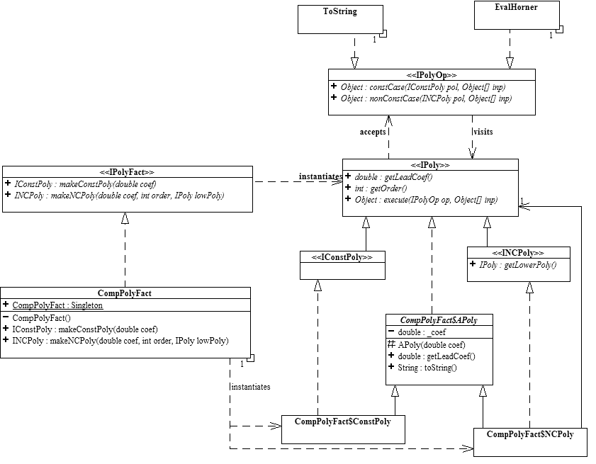

Division Algorithm:

Dividing one polynomial by another is exactly the same as long division of numbers, since each digit in a number represents a power of 10 and each element of a polynomial represents a power of x.

Let’s look at the first step of the process, since that’s all we really need for a recursive process:

$$\begin{aligned}{\left(a_{n}x^{n}+a_{n−1}x^{n−1}+a_{n−2}x^{n−2}\text{.}\text{.}\text{.}\text{.}\right)}/{\left(b_{m}x^{m}+b_{m−1}x^{m−1}+\text{.}\text{.}\text{.}\text{.}\right)}=\left(q_{n−m}x^{n−m}+q_{n−m−1}x^{n−m−1}+\text{.}\text{.}\text{.}\text{.}\right)+\text{remainder} \\ \\ ⇒\text{First step of the long division process:} \\ \\ \left(b_{m}x^{m}+b_{m−1}x^{m−1}+\text{.}\text{.}\text{.}\text{.}\right)\frac{\left(\frac{a_{n}}{b_{m}}x^{n−m}+q_{n−m−1}x^{n−m−1}\text{.}\text{.}\text{.}\text{.}\right) }{|\left(a_{n}x^{n}+a_{n−1}x^{n−1}+a_{n−2}x^{n−2}\text{.}\text{.}\text{.}\text{.}\right)} \\ \frac{−\left(\frac{a_{n}}{b_{m}}x^{n−m}\right)\left(b_{m}x^{m}+b_{m−1}x^{m−1}+\text{.}\text{.}\text{.}\text{.}\right) }{0+\left(a_{n−1}−\frac{a_{n}}{b_{m}}b_{m−1}\right)x^{n−1}+\left(a_{n−2}−\frac{a_{n}}{b_{m}}b_{m−2}\right)x^{n−2}+⋯} \\ \end{aligned}$$
We will be ignoring the remainder for this problem.

What we see is that the first term of the quotient is simply the quotient of the first terms of the dividend and divisor times x to the power of the difference in powers.

Note that the above discussion assumes that the order of the dividend (n) is larger than the order of divisor (m). We will discus more on the various cases below.

The first step above thus finishes the processing of the first term of the dividend (the “a” polynomial above) and gives us a result for the first term of the quotient.

To calculate the second term of the quotient, the problem reduces to the division of a “reduced” dividend polynomial, which is calculated by subtracting the product of the first term of the quotient and the divisor (the “b” polynomial above).

$$\left(b_{m}x^{m}+b_{m−1}x^{m−1}+\text{.}\text{.}\text{.}\text{.}\right)\frac{\left(q_{n−m−1}x^{n−m−1}+\text{.}\text{.}\text{.}\text{.}\right) }{|\left(a_{n−1}−\frac{a_{n}}{b_{m}}b_{m−1}\right)x^{n−1}+\left(a_{n−2}−\frac{a_{n}}{b_{m}}b_{m−2}\right)x^{n−2}+⋯}$$

This can thus be calculated by a simple recursive call.

There are a number of cases to consider however:

- Dividend is a constant polynomial and:
  - Divisor is a constant polynomial:
    - The quotient is simply a constant polynomial whose coefficient is the quotient of the dividend and divisor’s coefficients.
  - Divisor is a non-constant polynomial:
    - The quotient is simply a constant polynomial with a coefficient of zero.
- Dividend is a non-constant polynomial and:
  - Divisor is a constant polynomial:
    - This is a simplified case of the general discussion above.
    - The first term of the quotient is simply a non-constant polynomial whose coefficient is the quotient of the dividend and divisor’s coefficients and whose power is the same as the dividend’s.
    - The reduced dividend polynomial is simply the rest (lower polynomial) of the dividend. This is because the divisor only has one term.
    - The rest of the quotient can be calculated recursively using the reduced dividend polynomial.
  - Divisor is a non-constant polynomial and:
    - The dividend’s order is less than the divisor’s order:
      - The quotient is simply a constant polynomial with a coefficient of zero.
    - The dividend’s order equal’s the divisor’s order:
      - This is also a simplified case of the general discussion above that results in the quotient only have one (constant) term.
      - The coefficient if the constant polynomial quotient is simply the quotient of the dividend and divisor’s coefficients.
    - The dividend’s order is greater than the divisor’s order:
      - This is the same as the general discussion above.
      - The coefficient of the first term of the quotient is quotient of the dividend and divisor’s coefficients.
      - The power of the first term of the quotient is the difference in powers of the dividend and divisor.
      - The reduced dividend polynomial can be calculated by:
        - Multiplying the lower polynomial of the divisor by the negative of the first term of the quotient.
        - Then adding that result to the lower polynomial of the dividend.
        - Note that the first terms of the dividend and divisor can be ignored because they will cancel out by design.
      - The rest of the quotient can thus be calculated by recurring through the reduced dividend polynomial.

You are to write an IPolyOp algorithm called Div that will divide the host IPoly (the dividend) by an input IPoly (the divisor) returning an IPoly quotient.

Notes:
- Your code should minimize the use of conditionals, especially, it should never check for an order of zero, i.e. a constant polynomial.
- IPolyOp utility classes have been provided:
  - AddOp adds two polynomials together (Add is simply a different implementation of AddOp).
  - Mul multiplies two polynomials together.
  - MultMono multiplies the host polynomial with only the first term of an input parameter IPoly.
  - Note that these algorithms expect to see IPoly objects as their input parameters, so you may need to construct one using a zero-value coefficient polynomial as the lower polynomial if you don’t have one.

The stub and test code can be found in the polynomialCode subdirectory of the exam download.

Please insert your code for Div.java below:

- (60 pts) Higher order functions/visitors.

The provided zip file contains all the source code and project set-up for the problems in this section. The ILambda Leaf in package fp takes as input a non-empty BiTree and returns 1 if the tree is a leaf and 0 otherwise. A leaf is a tree whose subtrees are all empty. An empty tree is not a leaf. The JUnit test code TestLeaf in package fp.test illustrates how Leaf is used. You will need to use Leaf to aid in writing higher order BiTree visitors to count the leaves in a BiTree as specified in the following.

a/ Write a BiTree visitor called LeafCount that counts and returns all the leaves in a BiTree host in in-order traversal fashion. Complete the code for LeafCount in package brs.visitor as specified. The JUnit test code for LeafCount is TestLeafCount in package brs.test.

b/ Complete the JUnit test code TestLeafCount1 given in package brs.test to construct an in-order leaf counting visitor by composing the higher order in-order traversal visitor InOrder1 with an appropriate ILambda. Hint: take a look at TestLeafCount2 and TestLeafCount3.

